**Assignment No:- 8**

**Assignment Name:- Create a complete ASP.net web form for pizza ordering system . Take web server controls like dropdownlist for pizza selection radiobuttons for payment , textbox for name , textarea for address and onclick of submit button display users choice on the**

**screen. Apply appropriate validations.**

* **Default.aspx Page :-**

<%@ Page Language="C#" AutoEventWireup="true" CodeFile="Default.aspx.cs" Inherits="_Default" %>

<!DOCTYPE html>

<html xmlns="http://www.w3.org/1999/xhtml">

<head runat="server">

<title></title>

</head>

<body>

<form id="form1" runat="server">

<div>

<asp:Label ID="Label1" runat="server" Font-Bold="True" Font-Size="XX-Large" ForeColor="#000099" Text="Pizza Order System"></asp:Label>

<br />

<br />

<asp:Label ID="Label2" runat="server" Font-Bold="True" Font-Size="Large" Text="Customer Name : "></asp:Label>

<asp:TextBox ID="TextBox1" runat="server"></asp:TextBox>

<asp:RequiredFieldValidator ID="RequiredFieldValidator1" runat="server" ControlToValidate="TextBox1" ErrorMessage="Required...!!" ForeColor="Red"></asp:RequiredFieldValidator>

</div>

<p>

<asp:Label ID="Label3" runat="server" Font-Bold="True" Font-Size="Large" Text="Select Pizza :"></asp:Label>

&nbsp;<asp:DropDownList ID="DropDownList1" runat="server">

<asp:ListItem>Veggie Pizza</asp:ListItem>

<asp:ListItem>Cheese Pizza</asp:ListItem>

<asp:ListItem>Margherita Pizza</asp:ListItem>

<asp:ListItem>Corn Pizza</asp:ListItem>

<asp:ListItem>Paneer Pizza</asp:ListItem>

<asp:ListItem>Onion Pizza</asp:ListItem>

</asp:DropDownList>

<asp:RequiredFieldValidator ID="RequiredFieldValidator2" runat="server" ControlToValidate="DropDownList1" ErrorMessage="Required...!!" ForeColor="Red"></asp:RequiredFieldValidator>

</p>

<p>

<asp:Label ID="Label6" runat="server" Font-Bold="True" Font-Size="Large" Text="No of Pizza's : "></asp:Label>

<asp:TextBox ID="TextBox3" runat="server"></asp:TextBox>

<asp:RequiredFieldValidator ID="RequiredFieldValidator3" runat="server" ControlToValidate="TextBox3" ErrorMessage="Required...!!" ForeColor="Red"></asp:RequiredFieldValidator>

</p>

<p>

<asp:Label ID="Label4" runat="server" Font-Bold="True" Font-Size="Large" Text="Payment : "></asp:Label>

<asp:RadioButton ID="RadioButton1" runat="server" GroupName="P" Text="Cash On Delivery " />

<asp:RadioButton ID="RadioButton2" runat="server" GroupName="P" Text="UPI" />

</p>

<p>

<asp:Label ID="Label5" runat="server" Font-Bold="True" Font-Size="Large" Text="Address : "></asp:Label>

<asp:TextBox ID="TextBox2" runat="server" TextMode="MultiLine"></asp:TextBox>

<asp:RequiredFieldValidator ID="RequiredFieldValidator5" runat="server" ControlToValidate="TextBox2" ErrorMessage="Required...!!" ForeColor="Red"></asp:RequiredFieldValidator>

</p>

<p>

<asp:Button ID="Button1" runat="server" Font-Bold="True" Font-Size="Large" OnClick="Button1_Click" Text="Button" />

</p>

</form>

</body>

</html>

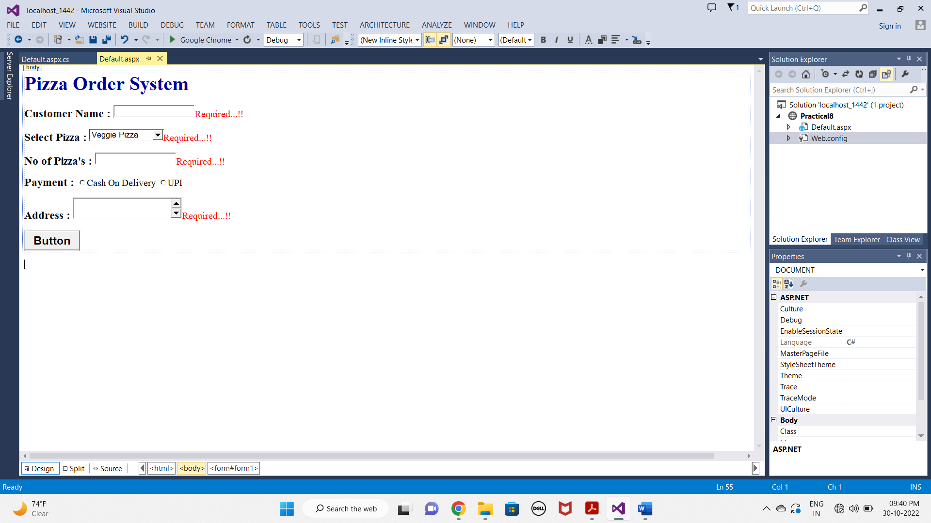

* **Default.aspx.cs Page :-**

using System;

using System.Collections.Generic;

using System.Linq;

using System.Web;

using System.Web.UI;

using System.Web.UI.WebControls;

public partial class _Default : System.Web.UI.Page

{

protected void Page_Load(object sender, EventArgs e)

{

}

protected void Button1_Click(object sender, EventArgs e)

{

Response.Write("Name : " + TextBox1.Text + "<br>");

Response.Write("Pizza Name : " + DropDownList1.SelectedItem.Text + "<br>");

Response.Write("No of Pizza's : " + TextBox3.Text + "<br>");

if (RadioButton1.Checked)

{

Response.Write("Payment : " + "Cash on Delivery"+"<br>");

}

else

{

Response.Write("Payment : " + "UPI"+"<br>");

}

Response.Write("Address is = " + TextBox2.Text + "<br>");

}

}

* **OUTPUT :-**

